Rewrite ETH_SRC

# Result

* L2 Rewrite “ETH_SRC” installation successfully but doesn’t pass the ping test

# Environment

|  |  |
| --- | --- |
| ONOS Version | 2.2.0.rc1 |
| ONOS OpenFlow Driver | Default |
| DGS-3630 | Firmware 2.22.B007 |

## ONOS Apps Activation

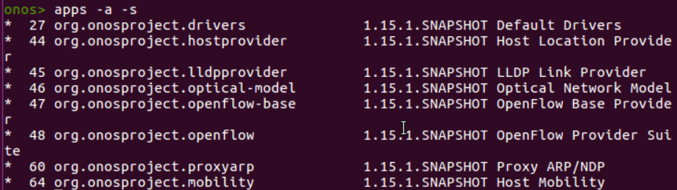

# Pipeline

DGS-3630 L2 Rewrite “ETH_SRC” would go through the pipeline as following:

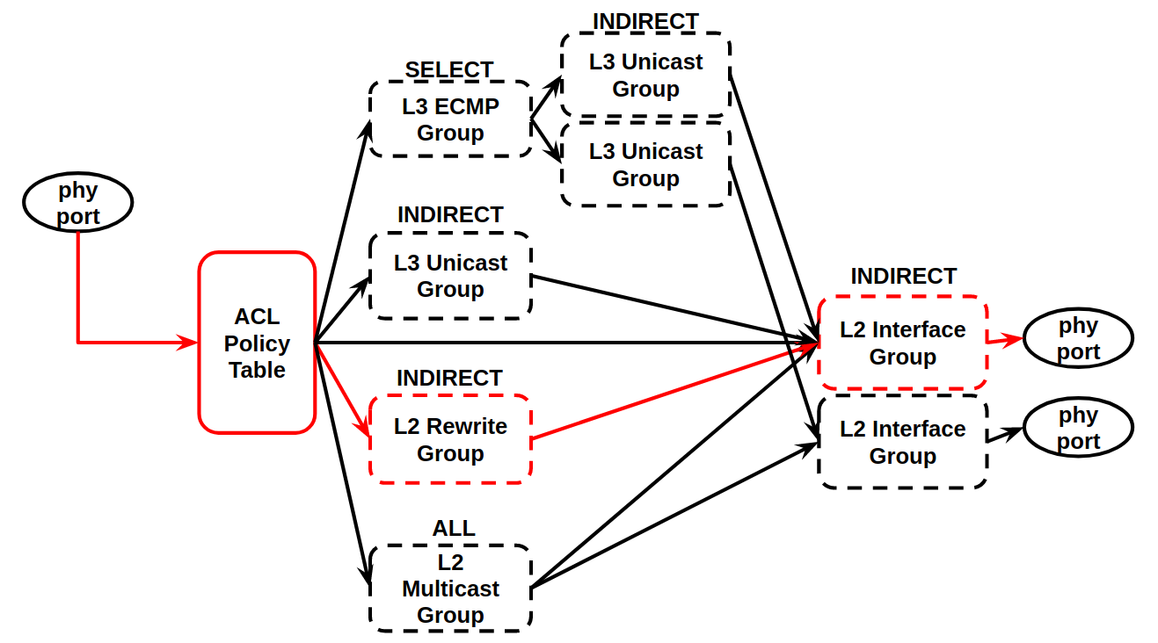

# Specific Format Requirment

Referring to the Spec. “*M2 (2019) > OpenFlow Test > DGS-3630 > Official Document > Appendix - OpenFlow Object Details.pdf*”, here grab the content and make a simple explain for this test using.

### 2.2 L2 Rewrite Group Entry Type

|  |  |
| --- | --- |
| Field | Description |
| Group Identifier | A 32 bit unsigned integer uniquely identifying the group on the  OpenFlow switch. The naming rule is shown in Table L2 Rewrite  Group Entry Naming Conversion. |
| Group Type | Indirect |
| Counters | Per-group entry counters are specified. |
| Action | Support single action bucket. |

### L2 Rewrite Group Entry Naming Conversion

|  |  |  |
| --- | --- | --- |
| Field | Bits | Description |
| Id | [27:0] | Index of differentiate group  entries of this type. |
| Kind | [31:28] | 1 (L2 Rewrite) |

* In this test, we use the id as following for L2 Rewrite Group:

|  |  |  |  |  |  |  |  |  |  |  |  |  |  |  |  |  |  |  |  |  |  |  |  |  |  |  |  |  |  |  |  |
| --- | --- | --- | --- | --- | --- | --- | --- | --- | --- | --- | --- | --- | --- | --- | --- | --- | --- | --- | --- | --- | --- | --- | --- | --- | --- | --- | --- | --- | --- | --- | --- |
| Kind | | | | ID | | | | | | | | | | | | | | | | | | | | | | | | | | | |
| 31 | 30 | 29 | 28 | 27 | 26 | 25 | 24 | 23 | 22 | 21 | 20 | 19 | 18 | 17 | 16 | 15 | 14 | 13 | 12 | 11 | 10 | 9 | 8 | 7 | 6 | 5 | 4 | 3 | 2 | 1 | 0 |
| 310 | | | | 110 | | | | | | | | | | | | | | | | | | | | | | | | | | | |
| 0 | 0 | 0 | 1 | 0 | 0 | 0 | 0 | 0 | 0 | 0 | 0 | 0 | 0 | 0 | 0 | 0 | 0 | 0 | 0 | 0 | 0 | 0 | 0 | 0 | 0 | 0 | 0 | 0 | 0 | 0 | 1 |
| 23 | 22 | 21 | 20 | 227 | 226 | 225 | 224 | 223 | 222 | 221 | 220 | 219 | 218 | 217 | 216 | 215 | 214 | 213 | 212 | 211 | 210 | 29 | 28 | 27 | 26 | 25 | 24 | 23 | 22 | 21 | 20 |

### L2 Rewrite Group Entry Bucket Actions

|  |  |
| --- | --- |
| Field | Description |
| Group | Must chain to a L2 Interface group entry. Required. |
| Set-Field | Set ETH_DST, ETH_SRC and VLAN_VID fields. Optional. |

### L2 Rewrite Group Entry Counters

|  |  |
| --- | --- |
| Field | Description |
| Reference Count (flow entries) | Number of flow or group entries currently referencing  this group entry. |
| Duration (seconds) | Seconds since this group entry was installed |

# Test Steps

## Step1. Install L2 Interface Group

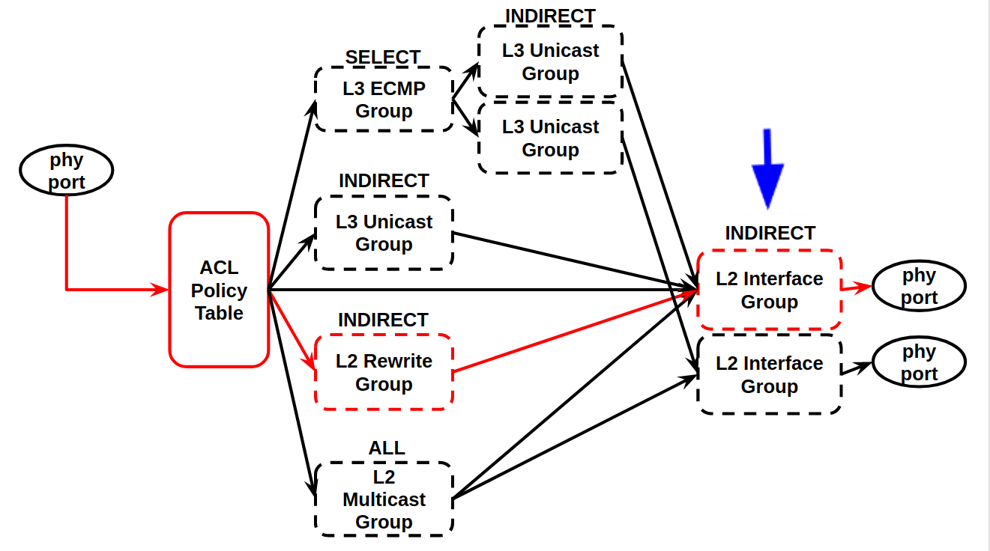

The group id as following for L2 Interface Group:

|  |  |  |  |  |  |  |  |  |  |  |  |  |  |  |  |  |  |  |  |  |  |  |  |  |  |  |  |  |  |  |  |
| --- | --- | --- | --- | --- | --- | --- | --- | --- | --- | --- | --- | --- | --- | --- | --- | --- | --- | --- | --- | --- | --- | --- | --- | --- | --- | --- | --- | --- | --- | --- | --- |
| Kind | | | | ID | | | | | | | | | | | | | | | | | | | | | | | | | | | |
| 31 | 30 | 29 | 28 | 27 | 26 | 25 | 24 | 23 | 22 | 21 | 20 | 19 | 18 | 17 | 16 | 15 | 14 | 13 | 12 | 11 | 10 | 9 | 8 | 7 | 6 | 5 | 4 | 3 | 2 | 1 | 0 |
| 310 | | | | 110 | | | | | | | | | | | | | | | | | | | | | | | | | | | |
| 0 | 0 | 0 | 0 | 0 | 0 | 0 | 0 | 0 | 0 | 0 | 0 | 0 | 0 | 0 | 1 | 0 | 0 | 0 | 0 | 0 | 0 | 0 | 0 | 0 | 0 | 0 | 0 | 0 | 0 | 1 | 0 |
| 23 | 22 | 21 | 20 | 227 | 226 | 225 | 224 | 223 | 222 | 221 | 220 | 219 | 218 | 217 | 216 | 215 | 214 | 213 | 212 | 211 | 210 | 29 | 28 | 27 | 26 | 25 | 24 | 23 | 22 | 21 | 20 |

* Kind=0, L2 Interface
* Interface ID=2, for output port is 2

curl L2 Interface Group Entry:

|  |
| --- |
| $ curl –u onos:rocks –X POST –H “Content-type: application/json” -d @group222.json http://localhost:8181/onos/v1/groups/of:000078321bdf7600 |

* group222.json

|  |
| --- |
| {   "type":"INDIRECT",  "appCookie":"0x1234abc3",  "groupId":"65538",  "buckets":[  {   "treatment":{  "instructions":[  {  "type":"OUTPUT",  "port":"2"  }  ]  }   }   ] } |

## Step2. Install L2 Rewirte Group

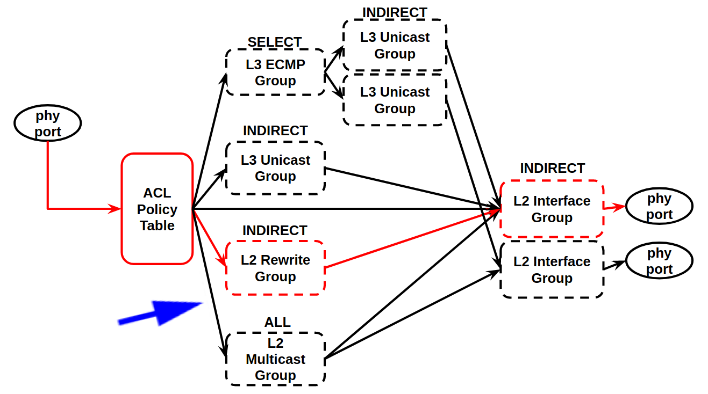

|  |  |  |  |  |  |  |  |  |  |  |  |  |  |  |  |  |  |  |  |  |  |  |  |  |  |  |  |  |  |  |  |
| --- | --- | --- | --- | --- | --- | --- | --- | --- | --- | --- | --- | --- | --- | --- | --- | --- | --- | --- | --- | --- | --- | --- | --- | --- | --- | --- | --- | --- | --- | --- | --- |
| Kind | | | | ID | | | | | | | | | | | | | | | | | | | | | | | | | | | |
| 31 | 30 | 29 | 28 | 27 | 26 | 25 | 24 | 23 | 22 | 21 | 20 | 19 | 18 | 17 | 16 | 15 | 14 | 13 | 12 | 11 | 10 | 9 | 8 | 7 | 6 | 5 | 4 | 3 | 2 | 1 | 0 |
| 310 | | | | 110 | | | | | | | | | | | | | | | | | | | | | | | | | | | |
| 0 | 0 | 0 | 1 | 0 | 0 | 0 | 0 | 0 | 0 | 0 | 0 | 0 | 0 | 0 | 1 | 0 | 0 | 0 | 0 | 0 | 0 | 0 | 0 | 0 | 0 | 0 | 0 | 0 | 0 | 1 | 0 |
| 23 | 22 | 21 | 20 | 227 | 226 | 225 | 224 | 223 | 222 | 221 | 220 | 219 | 218 | 217 | 216 | 215 | 214 | 213 | 212 | 211 | 210 | 29 | 28 | 27 | 26 | 25 | 24 | 23 | 22 | 21 | * 20 |

curl L2 Multicast Group Entry:

|  |
| --- |
| $ curl –u onos:rocks –X POST –H “Content-type: application/json” -d @group111.json http://localhost:8181/onos/v1/groups/of:000078321bdf7600 |

* group111.json

|  |
| --- |
| {  "type":"INDIRECT",  "appCookie":"0x2234abc3",  "groupId":"268500994",  "buckets":[  {   "treatment":{  "instructions":[  {  "type":"L2MODIFICATION",  "subtype": "ETH_SRC",  "mac": "d0:94:66:5d:5e:07"  },  {  "type":"GROUP",  "groupId":"65538",  }  ]  }   }   ] } |

## Step3. Install Flow to go to group entry

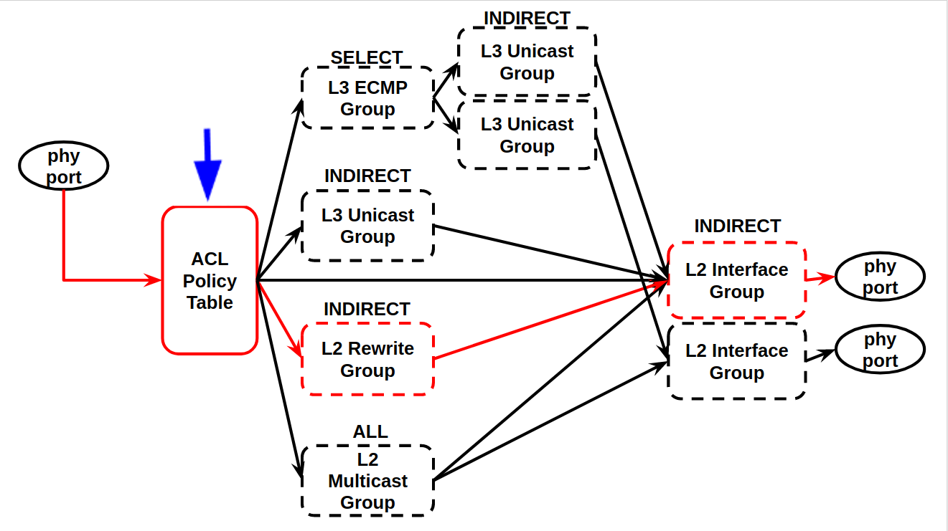

curl Flow Write-Actions:

|  |
| --- |
| $ curl -u onos:rocks -X POST -H "Content-type: application/json" -d @flowethsrc.json http://localhost:8181/onos/v1/flows |

* flow.json

|  |
| --- |
| {   "flows":[  {   "priority":100,  "timeout":0,  "isPermanent":true,  "deviceId":"of:000078321bdf7000",  "treatment":{  "instructions": [],  "deferred": [  {  "type":"GROUP",  "groupId":"268500994"  }  ]  },   "selector":{  "criteria":[  {  "type":"IN_PORT",  "port":"1"  }  ]  }  }   ] } |

## Step4. test1 ping test2

ping -c 5 -I enp4s0 192.168.205.2

## Step5. test2 tcpdump

ping -c 5 -I enp4s0 192.168.205.1

# Conclusion



L2 Rewrite “ETH_SRC” installation successfully but doesn’t pass the ping test

## ONOS GUI in Group Table

## ONOS GUI in Flow Table

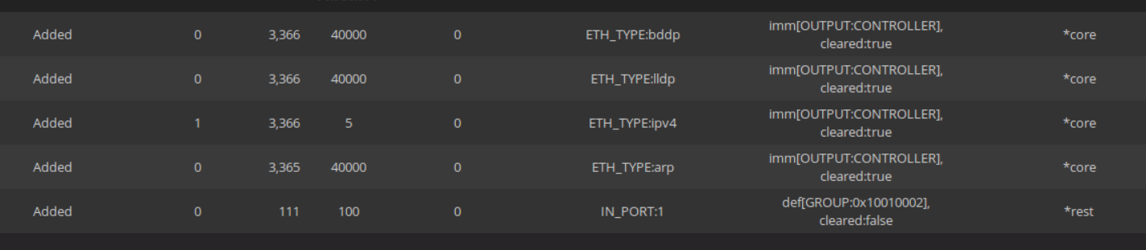

## DGS-3630 CLI in Group Entries

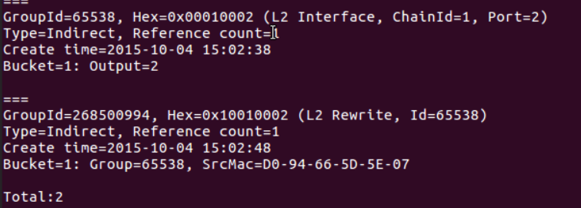

sudo tcpdump -nni enp4s0 -e ip

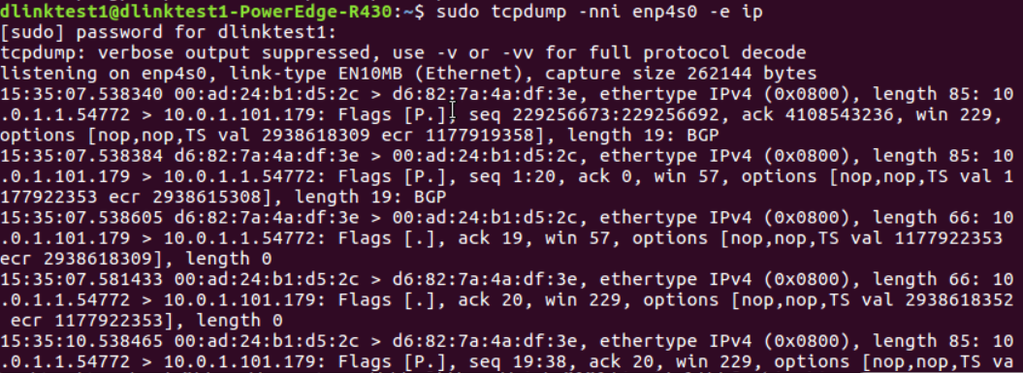

sudo tcpdump -nni enp4s0 -e src 192.168.205.1

